**EBS (Elastic block Storage)**

1. Created instance with 8GB root EBS volume and 1GB with EBS volume

Root EBS volume mount point is /dev/xvda

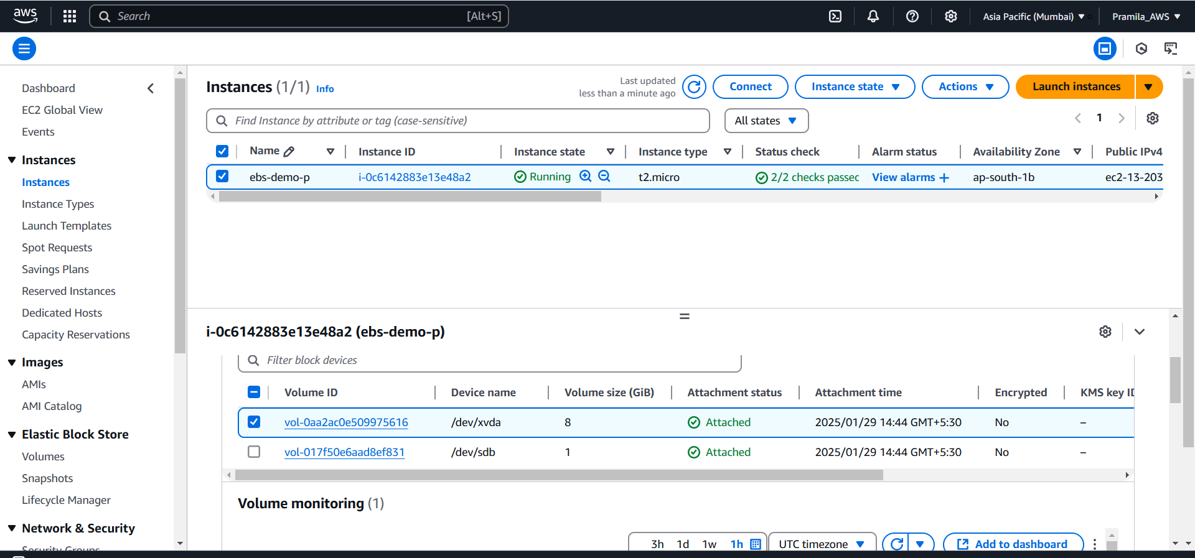

1. Connect to instance using putty to check root ebs and ebs volumes using cmd ‘df –h’ and lsblk

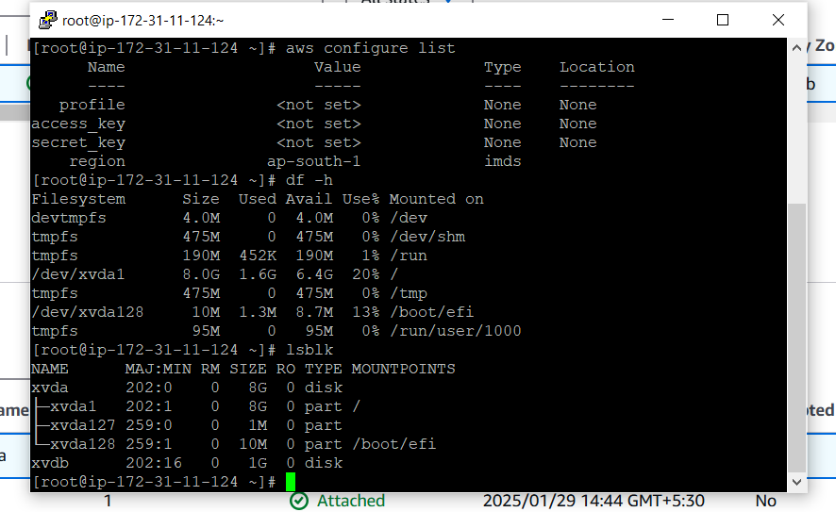

1. To check ebs volume have any data we use cmd ‘file –s /dev/xvdb’ (ebs volume point)

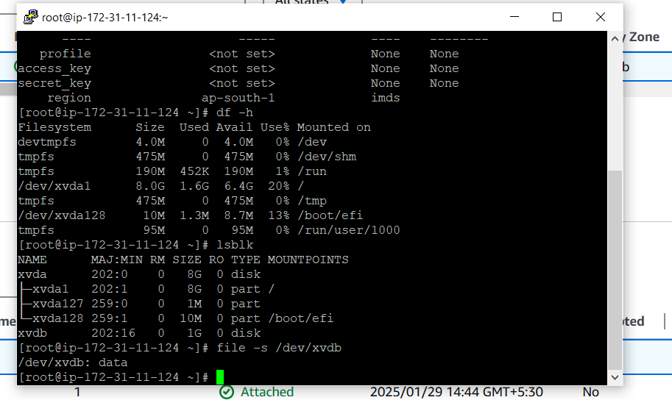

1. Format ebs volume using cmd ‘mkfs –t ext4 /dev/xvdb’

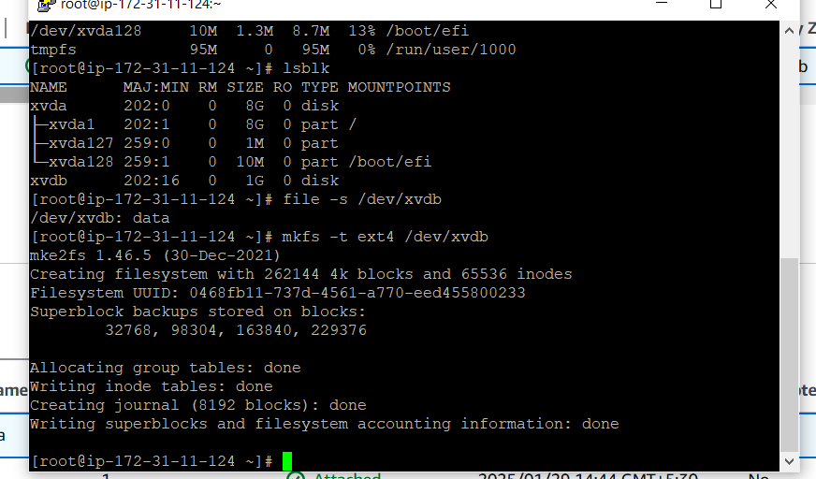

1. Make directory to mount ebs volume using cmd ‘mkdir app1’

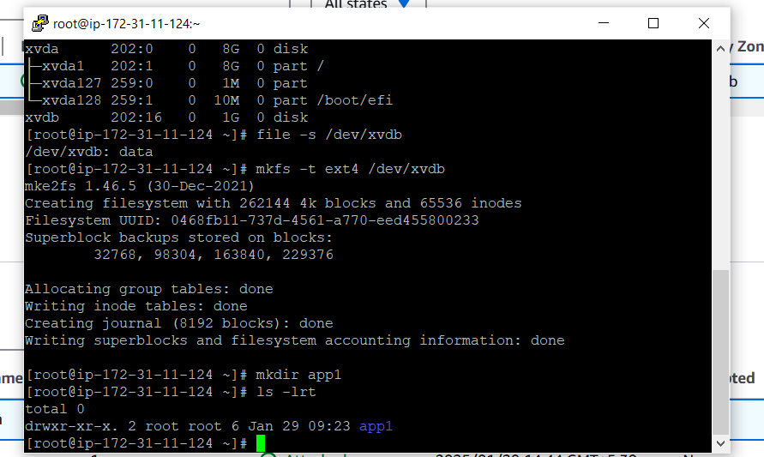

1. Mount ebs volume to dir app1 suing cmd ‘mount /dev/xvdb app1’

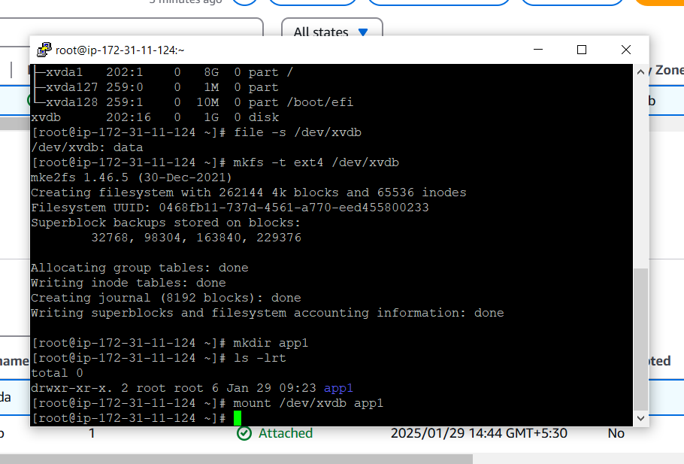

1. Create new ebs volume to attach to instance. EBS volume and instance should be same Availability Zone.

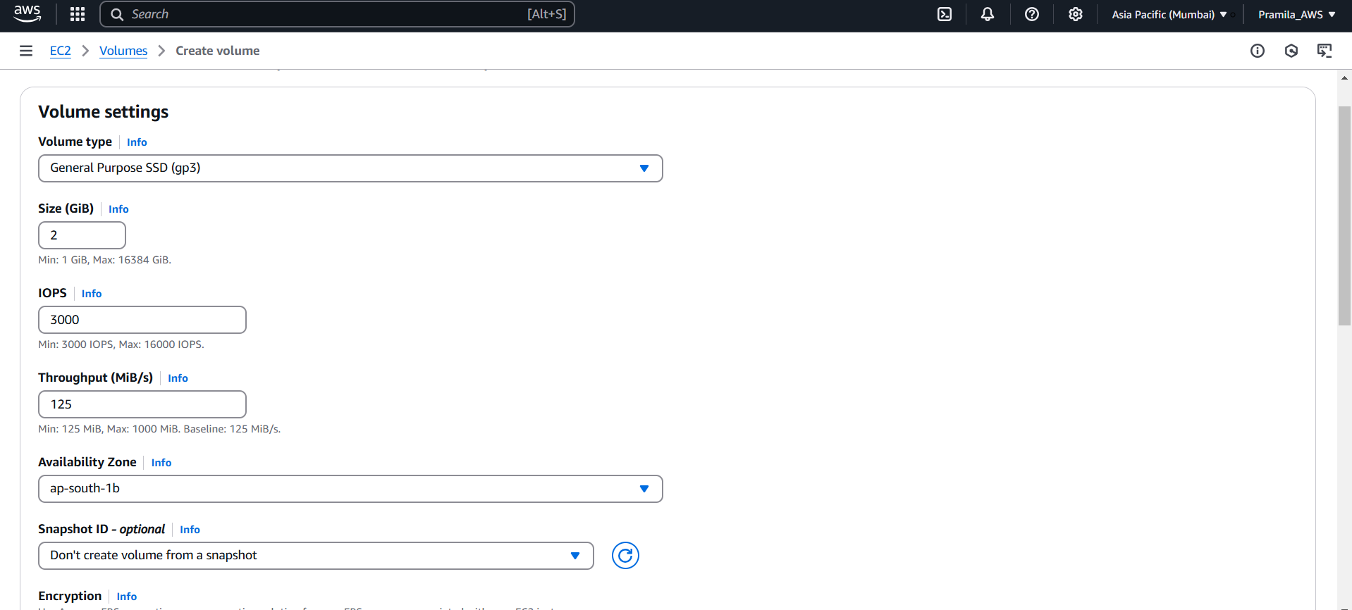

1. New 2GB EBS volume get created

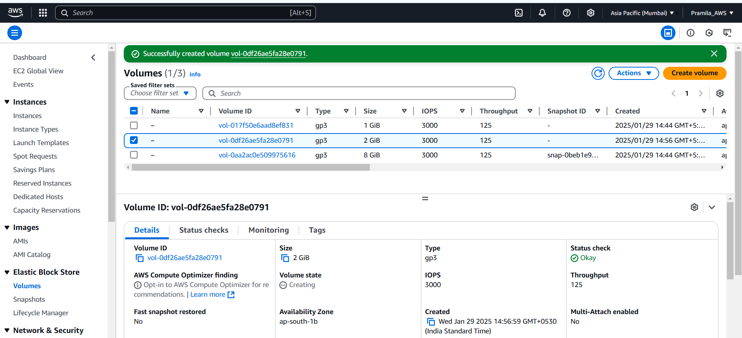

1. Attach new 2 GB EBS volume to instance

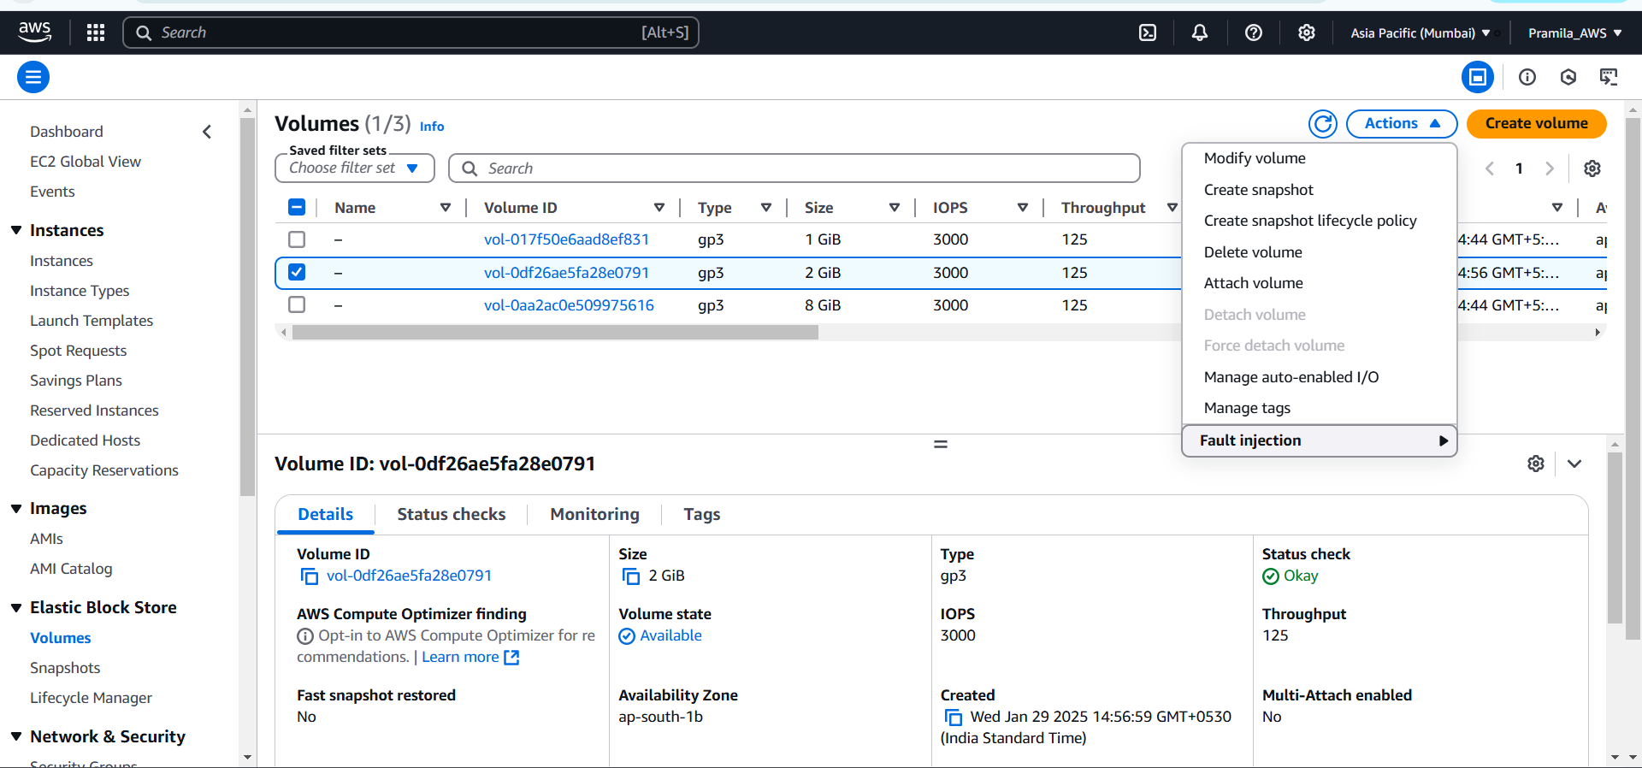

1. Select instance and device name for new ebs volume

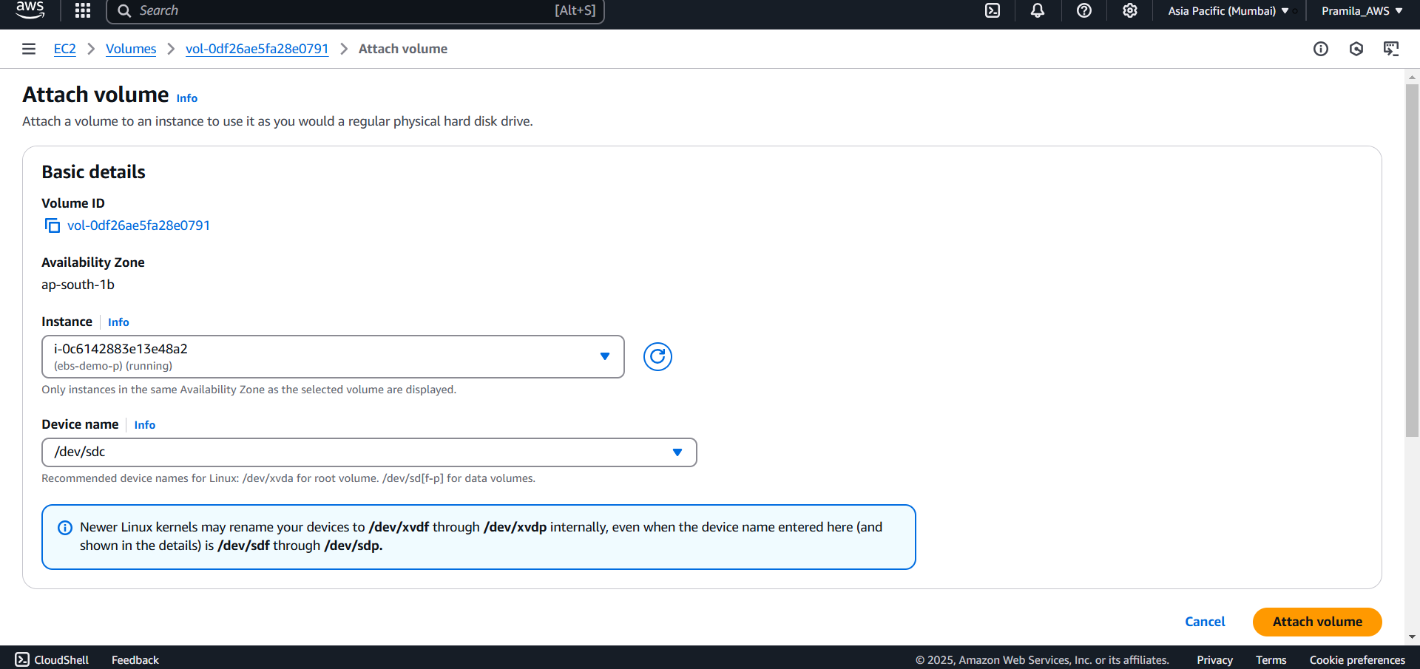

1. Attached new EBS volume to instance

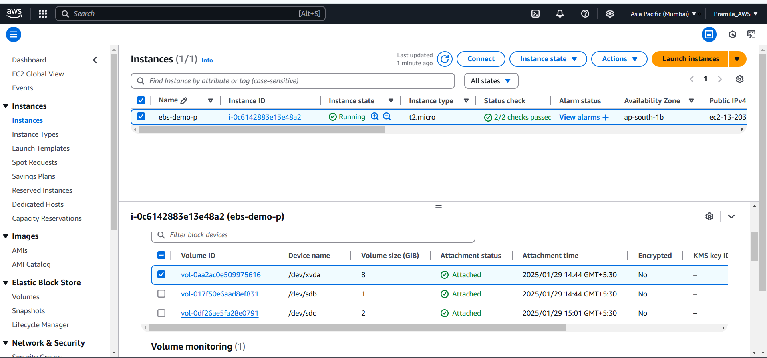

1. Check volume using cmd ‘lsblk’

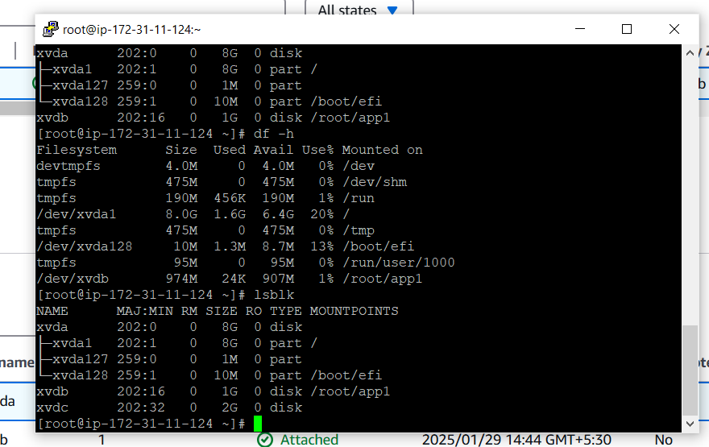

1. Fomat new added volume using command ‘mkfs –t ext4 /dev/xvdc’

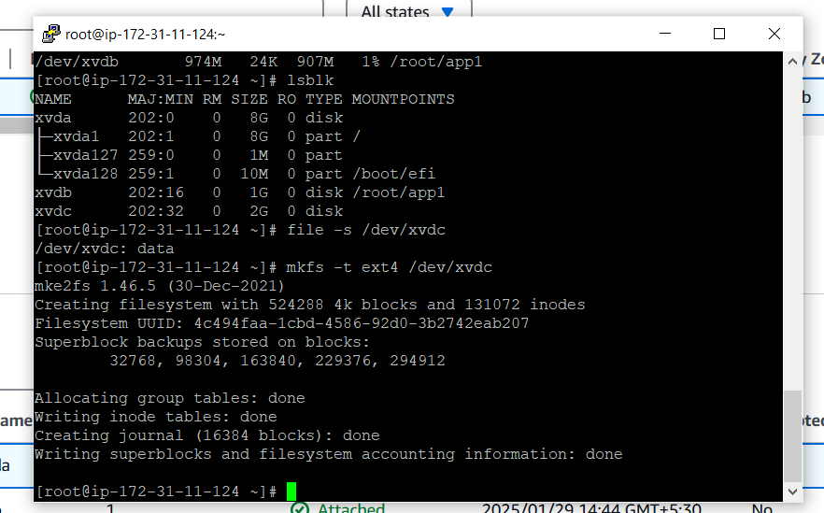

1. Create directory app2 and Mount volume to directory suing command ‘mount /dev/xvdc app2’

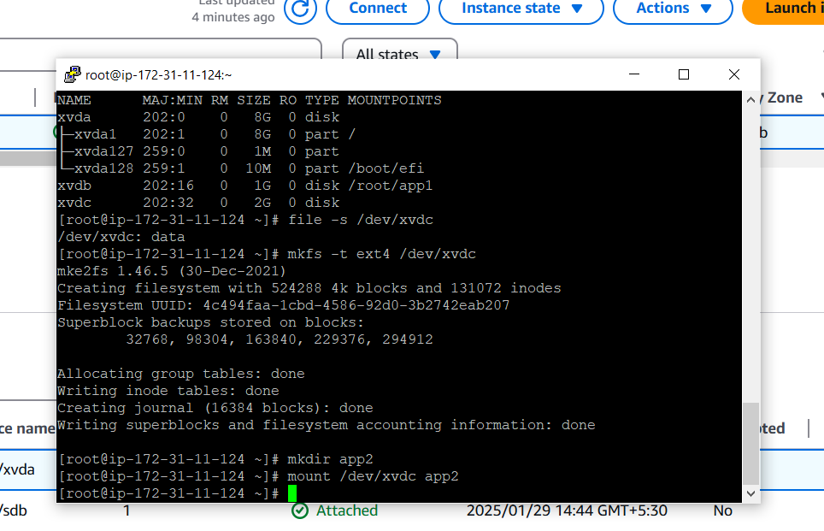

1. All attached volume of instance

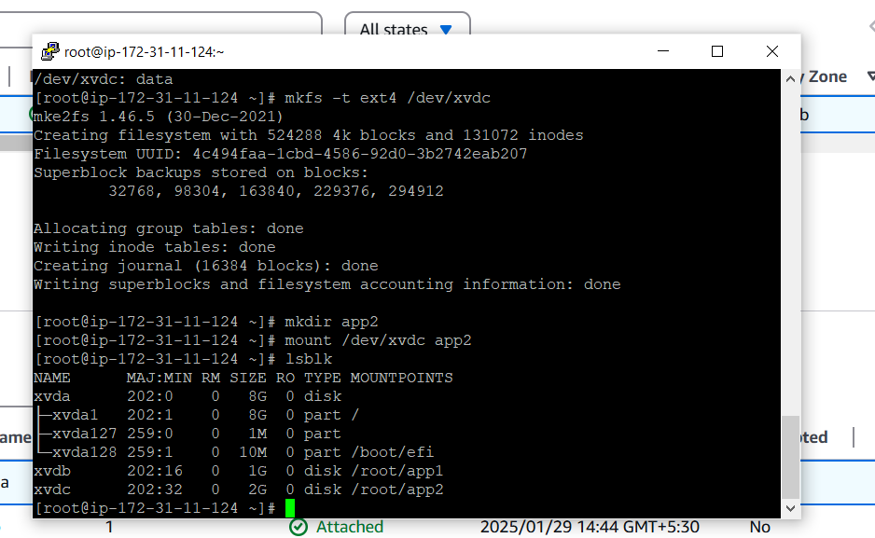

1. Detach volume from instance. We can detach EBS volumes without stopping the instance.

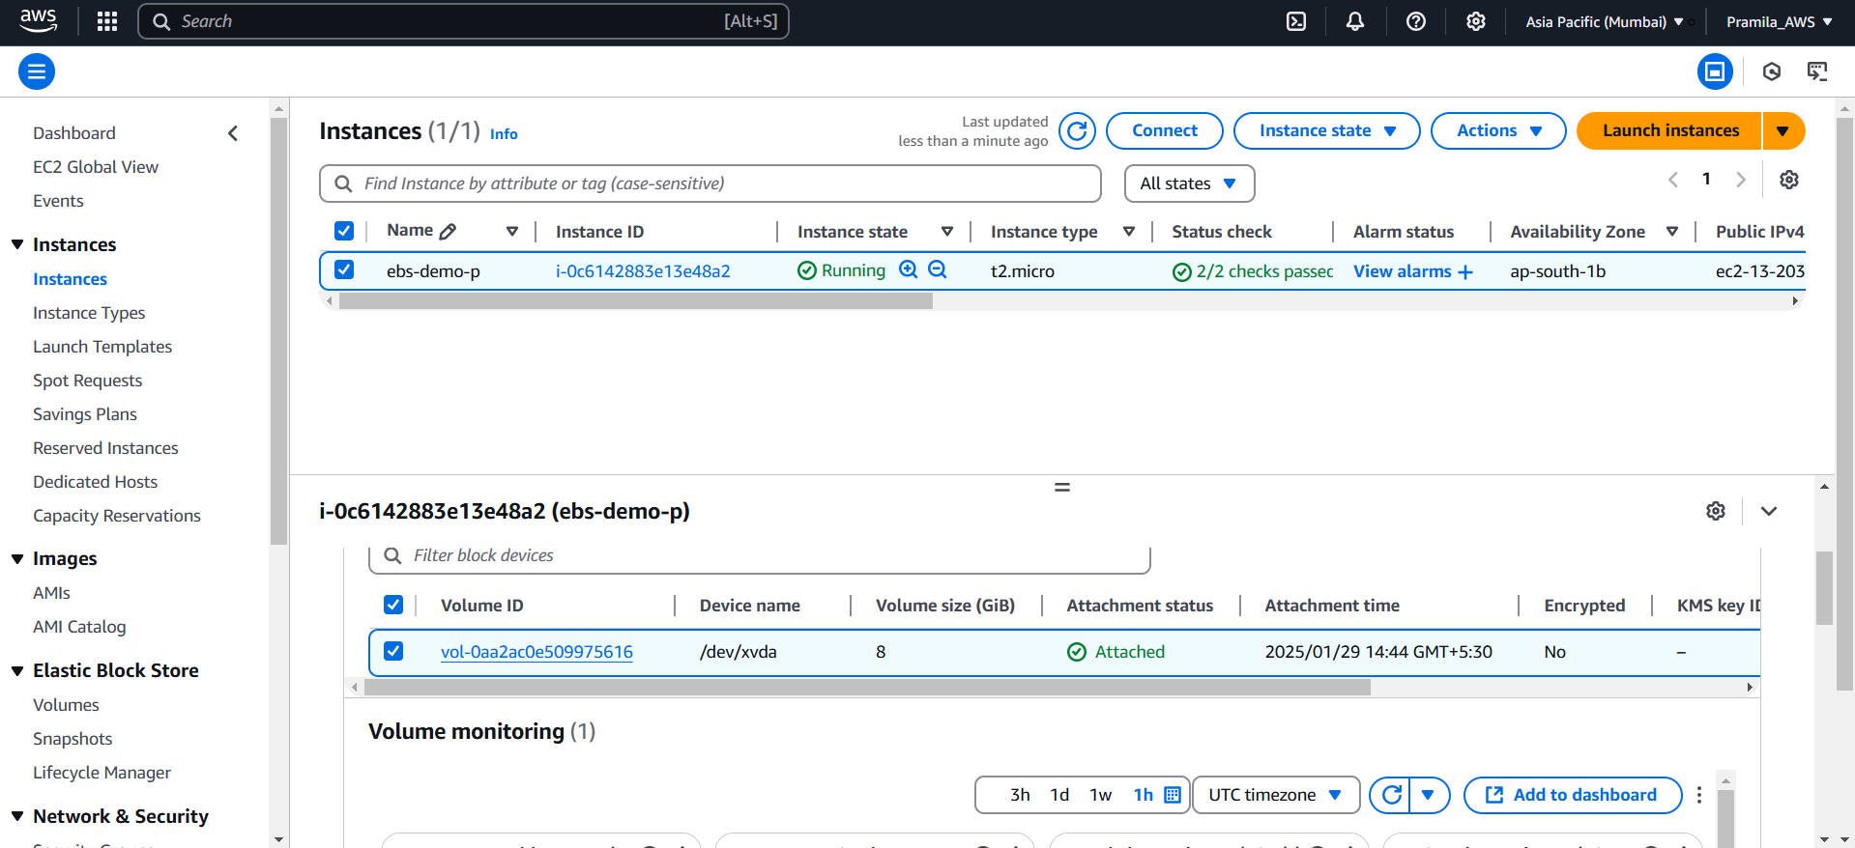

1. We cann’t detach root EBS volume unless instance get stopped

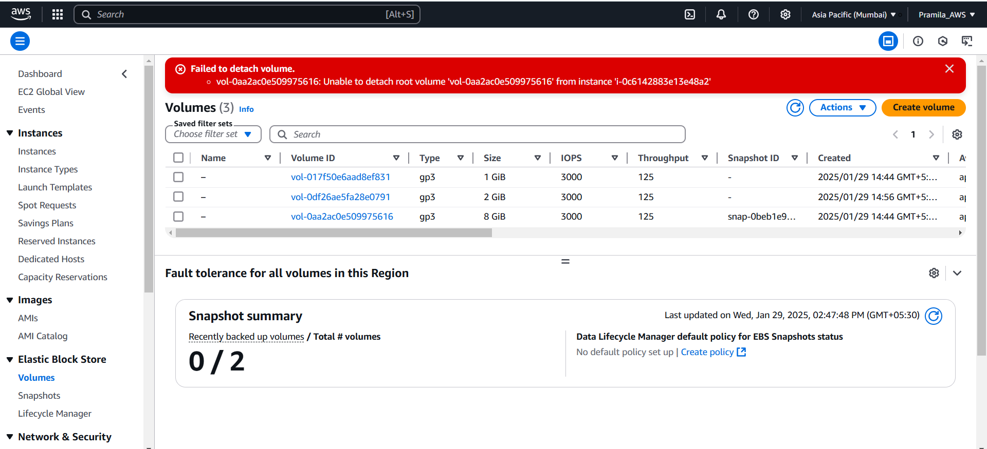

1. First we need to stop the instance then only we can detach root ebs volume

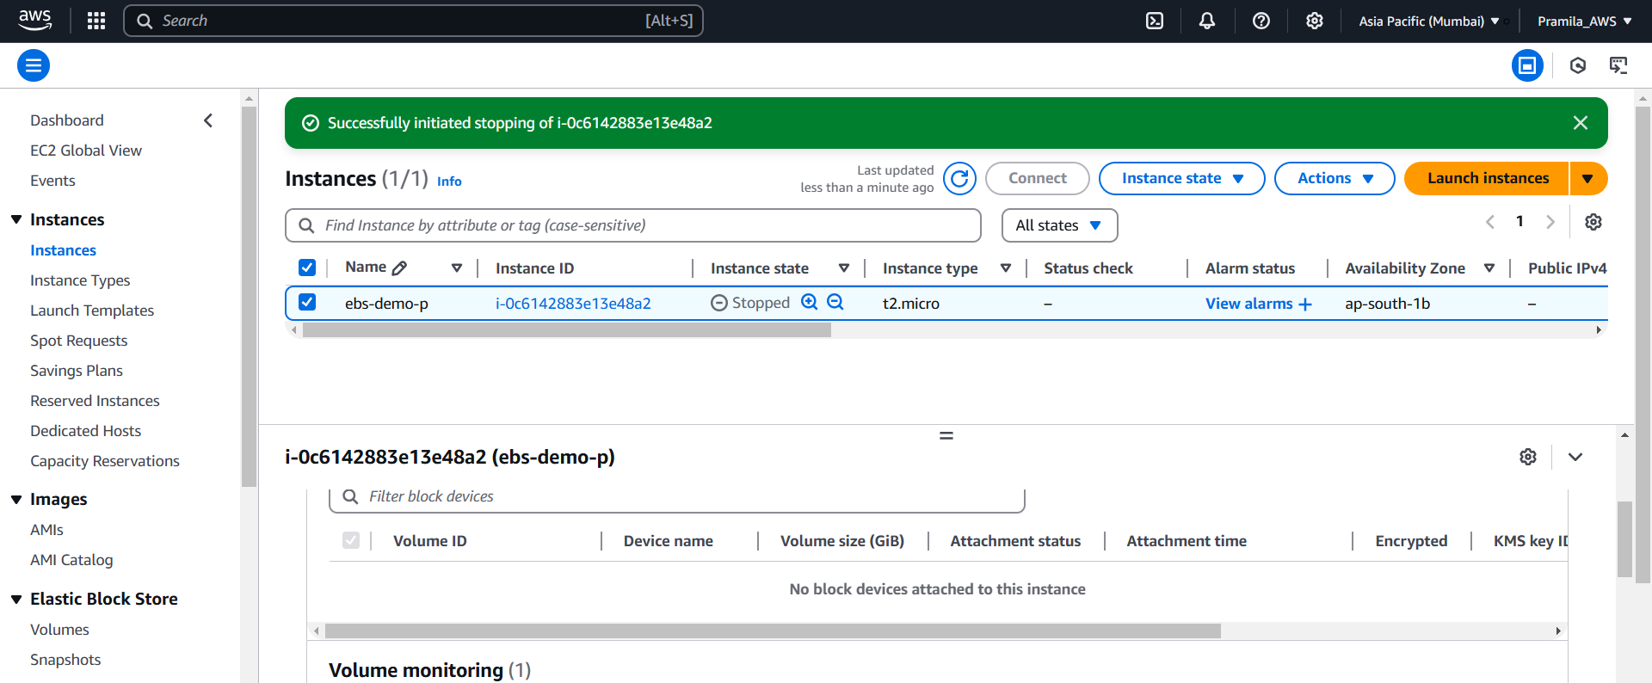

**Increase Root EBS volume size**

1. First we need to create snapshot of root ebs volume

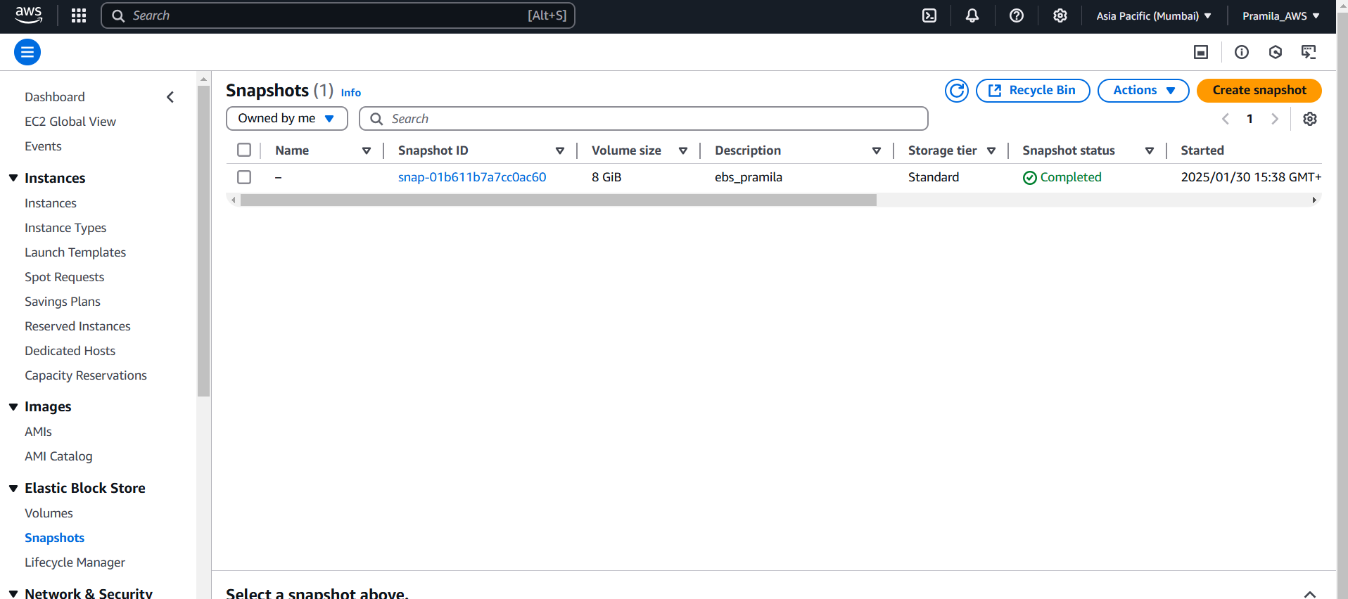

1. Create volume from snapshot

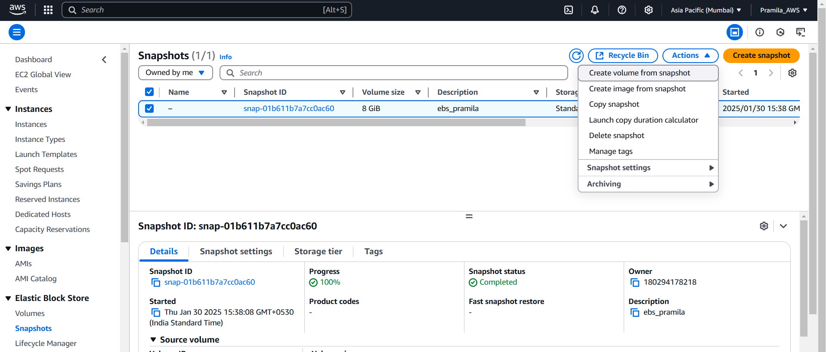

1. Stopped the instance to remove root ebs volume

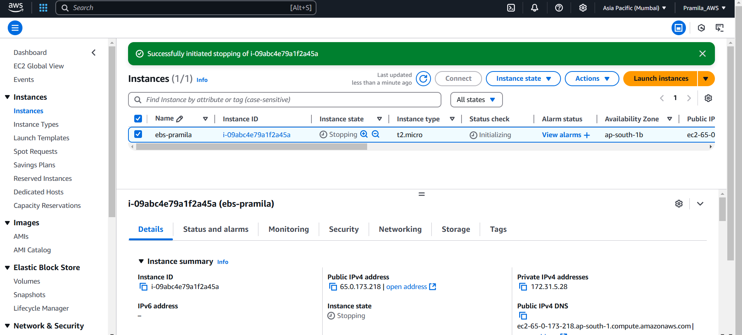

1. Detach root ebs volume after instance get stopped

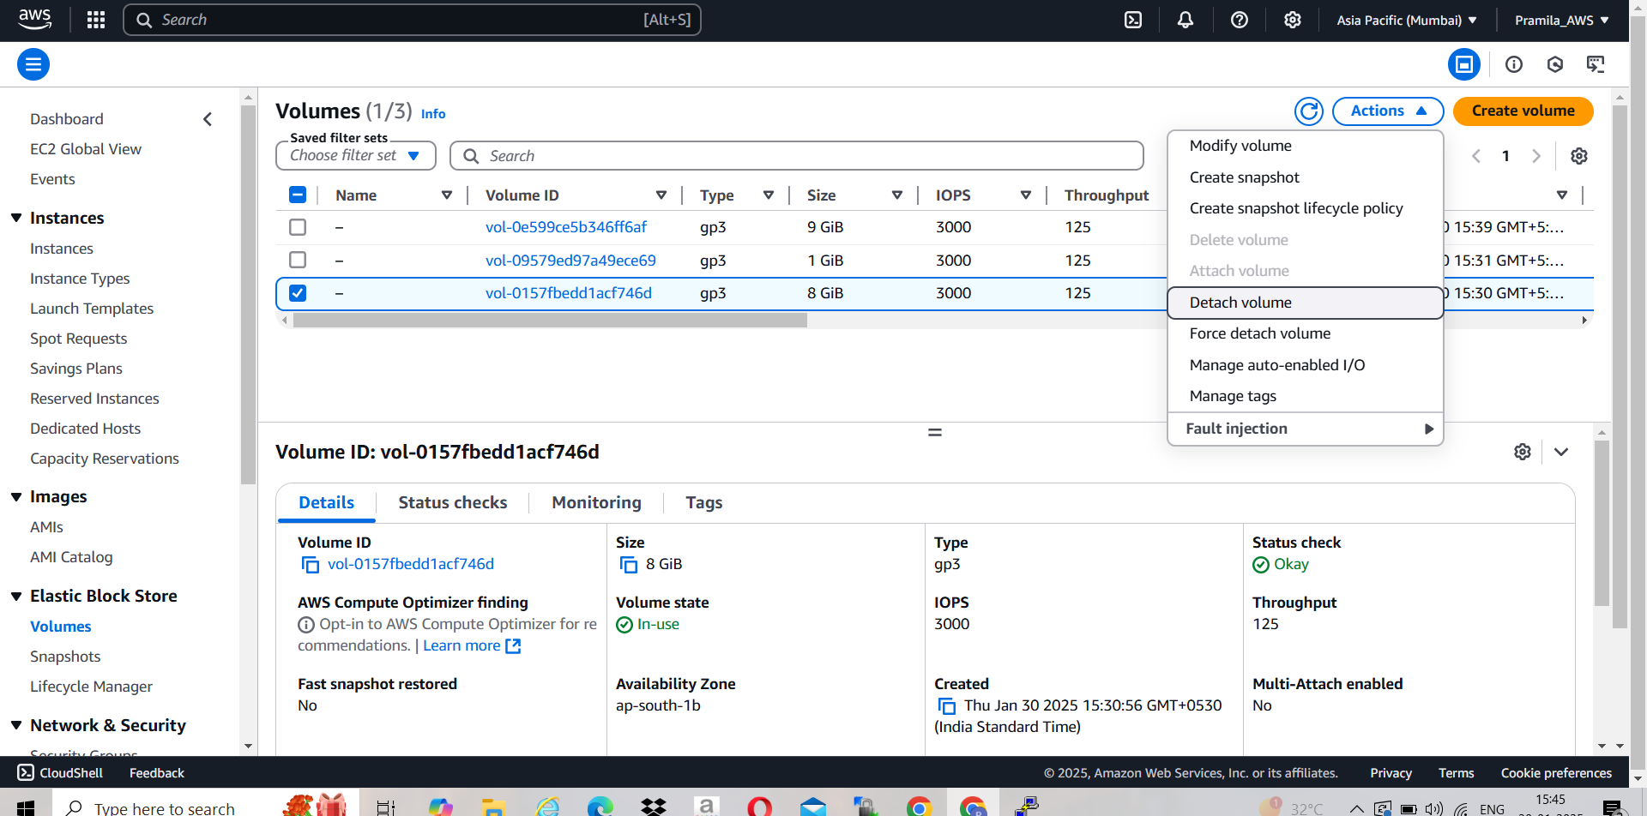

1. Attach new ebs volume(9GB) which is created from snapshot

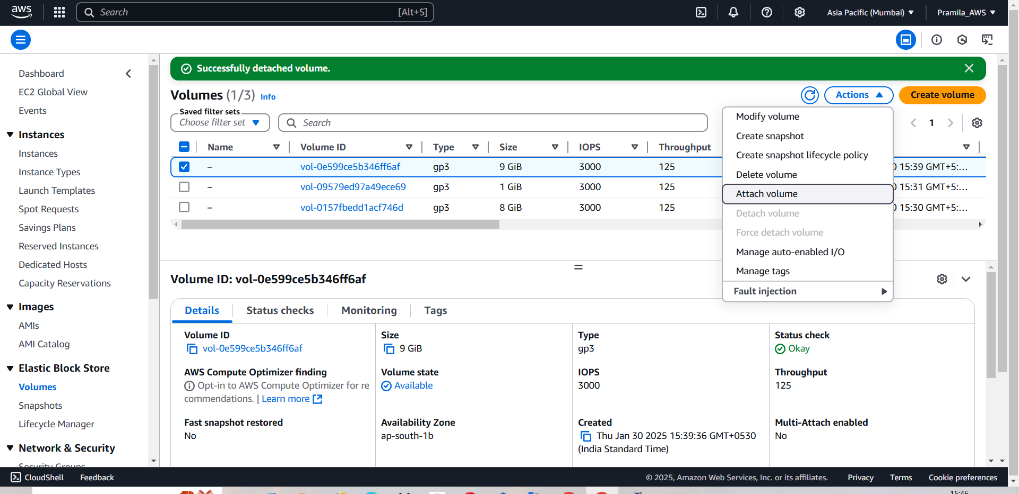

1. Select device name as a root mount point ‘/dev/xvda’

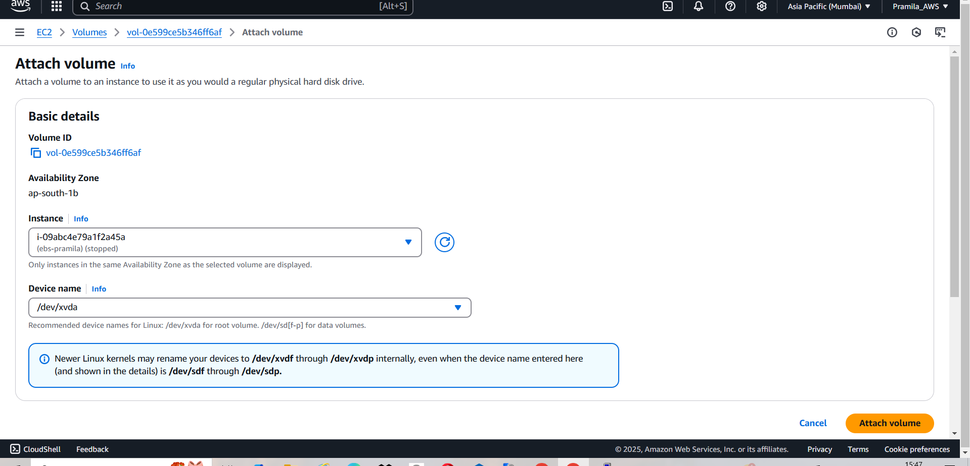

1. Root ebs volume size get increased from 8GB to 9 GB

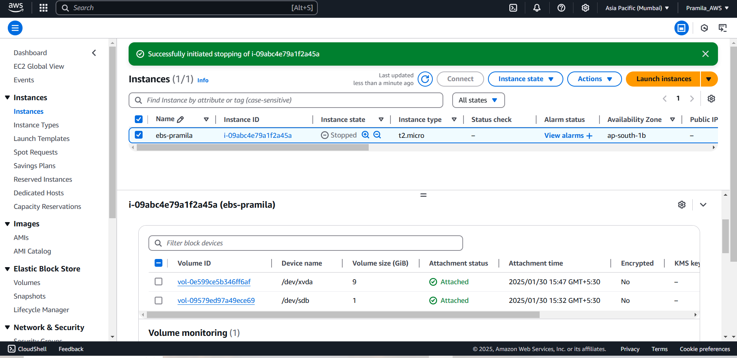

1. Check using cmd lsblk

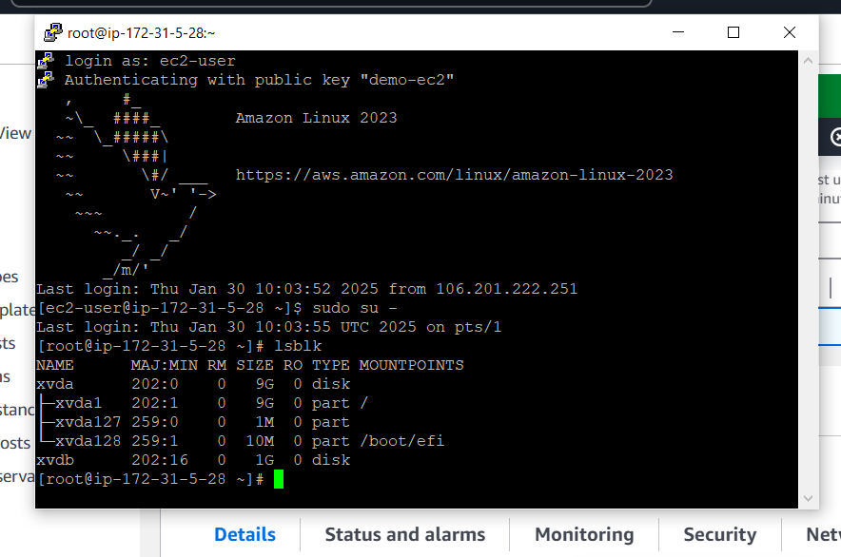

1. Now we can modify ebs volume size from 1GB to 2GB directly

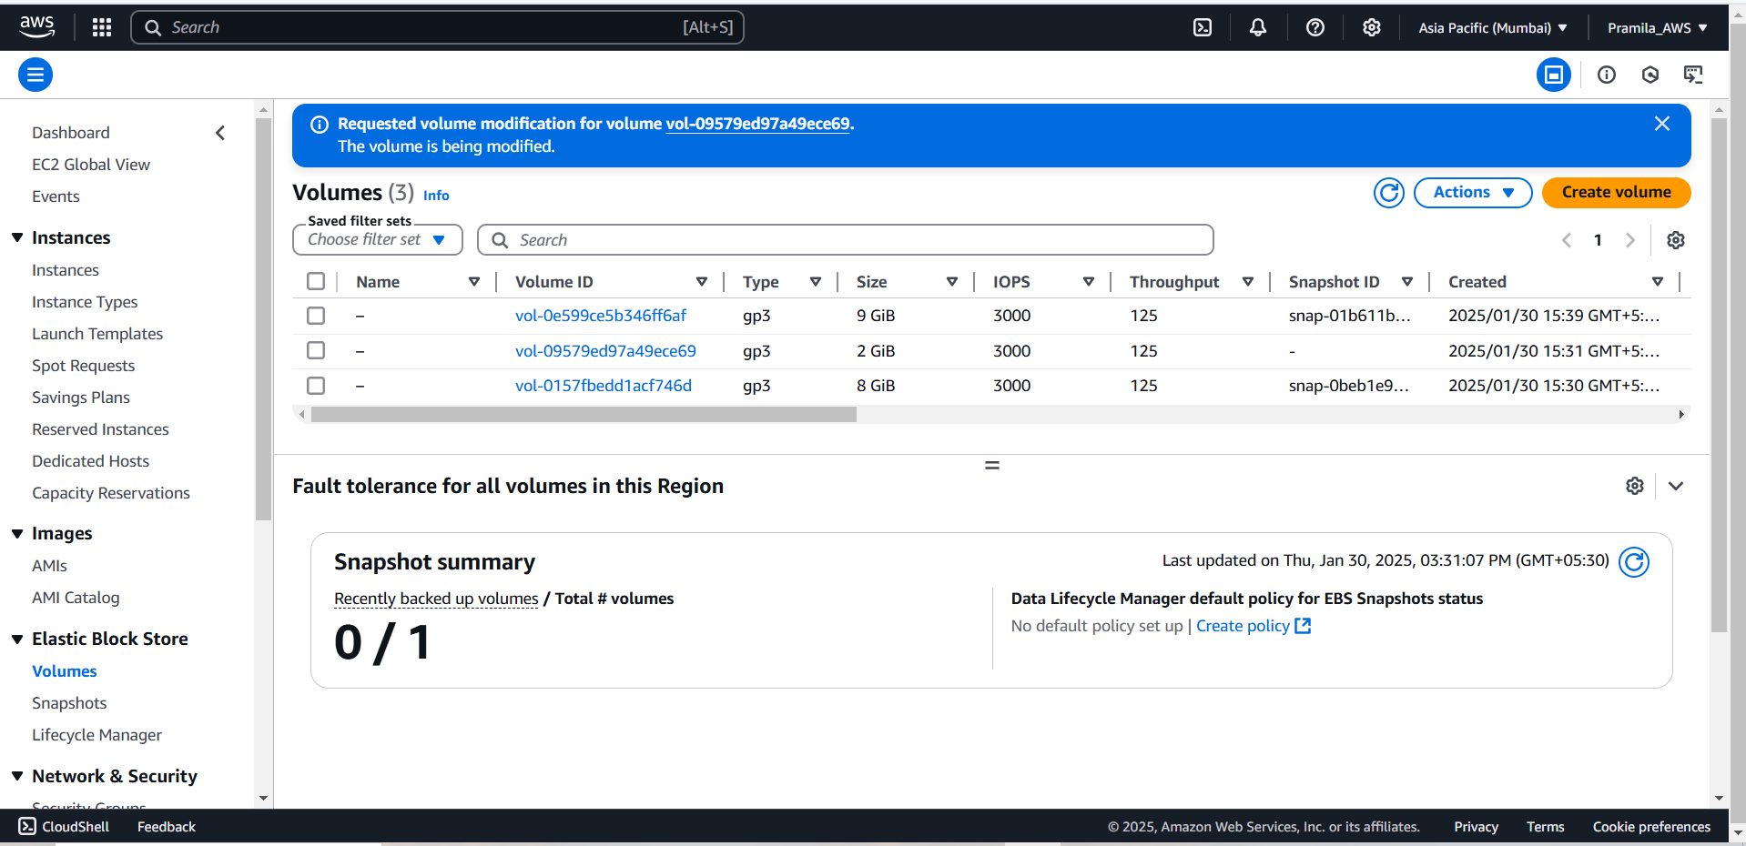

1. EBS volume size is now 2GB

